Protecting database (Security configuration)

Security measures at a database level. (There is a whole certification from Microsoft)

By default if no user is created it has admin rights

From DB - in security folder ( new -> login)

Tmur fuq il user min go database security folder (gol actual db mhux ta barra)

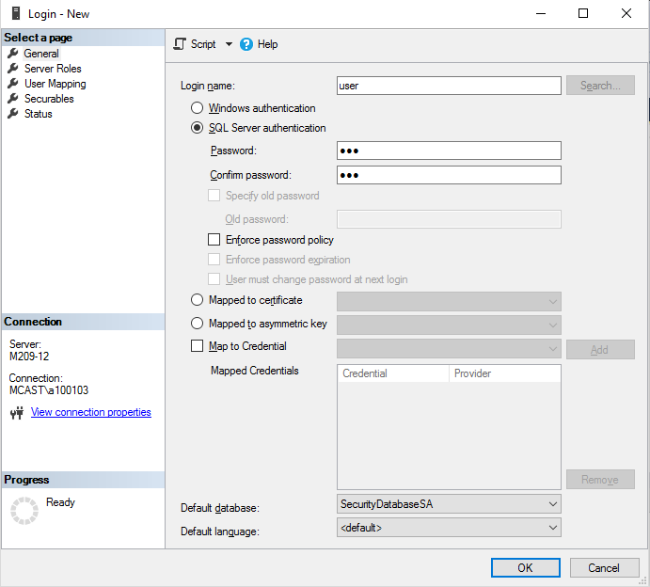

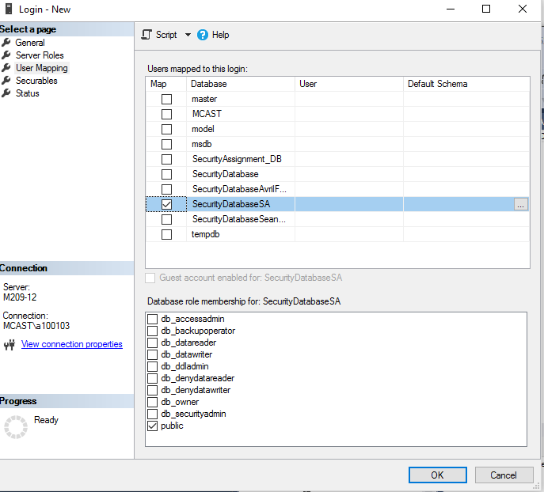

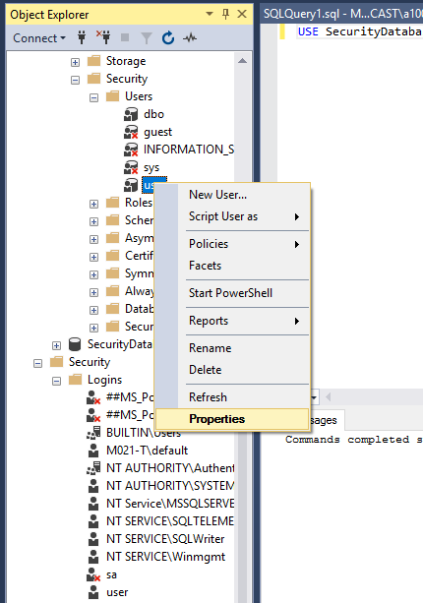

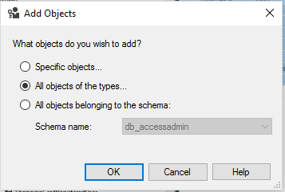

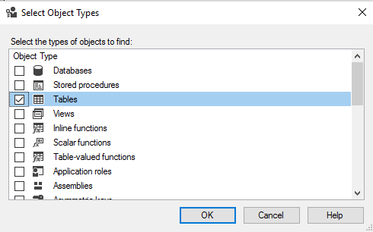

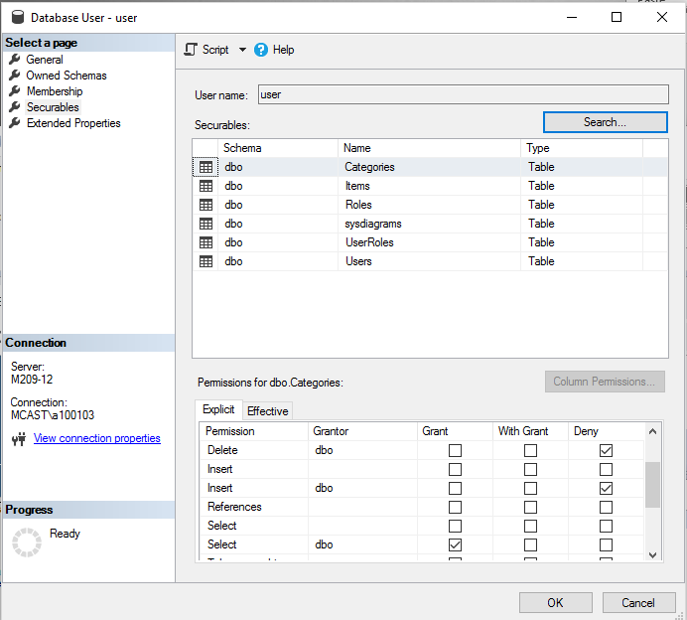

Assigning permissions to different roles (group of users)

Deny is set by default , namlu deny fuq update, delete , insert u grant fuq select.

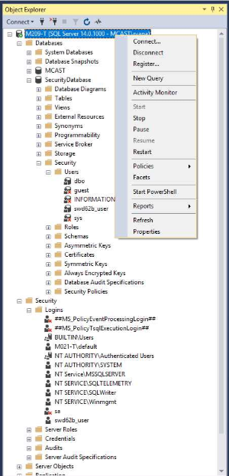

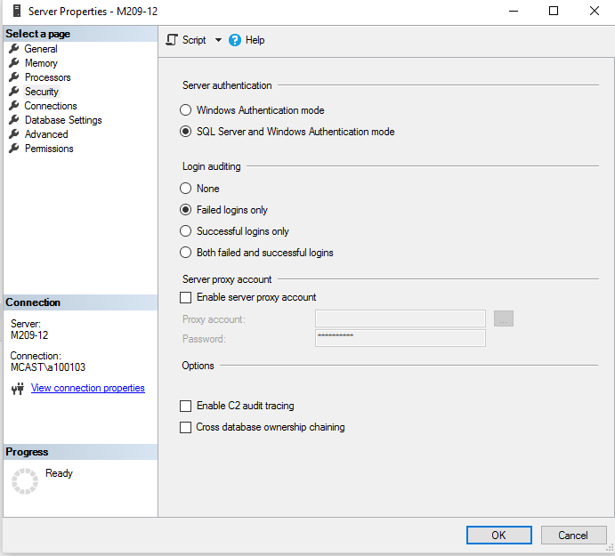

Tamel restart ta service wara din l action jew restart pc.

Inside web.config :

Datasource – servername / pc name

Initial catalog = Name of database

Integrated security = for windows authentication only ?

Create another connection string for a user.

Connection string ta gol common biex jupdatja l model qeda

Tal webconfig limportanti (ghax tal website.)